EX NO:02
DATE:
EL HORNO'S PIZZA BI ANALYSIS

AIM:
Problem Statement: You have been hired as a BI Analyst by El Horno’s Pizza. The company is trying to assess marketing strategy effectiveness and sales distribution across different products. The Director of the company has asked you to show the following:

- Sales trend across 2 product categories, Pizza and Burger. Build an Area Chart.
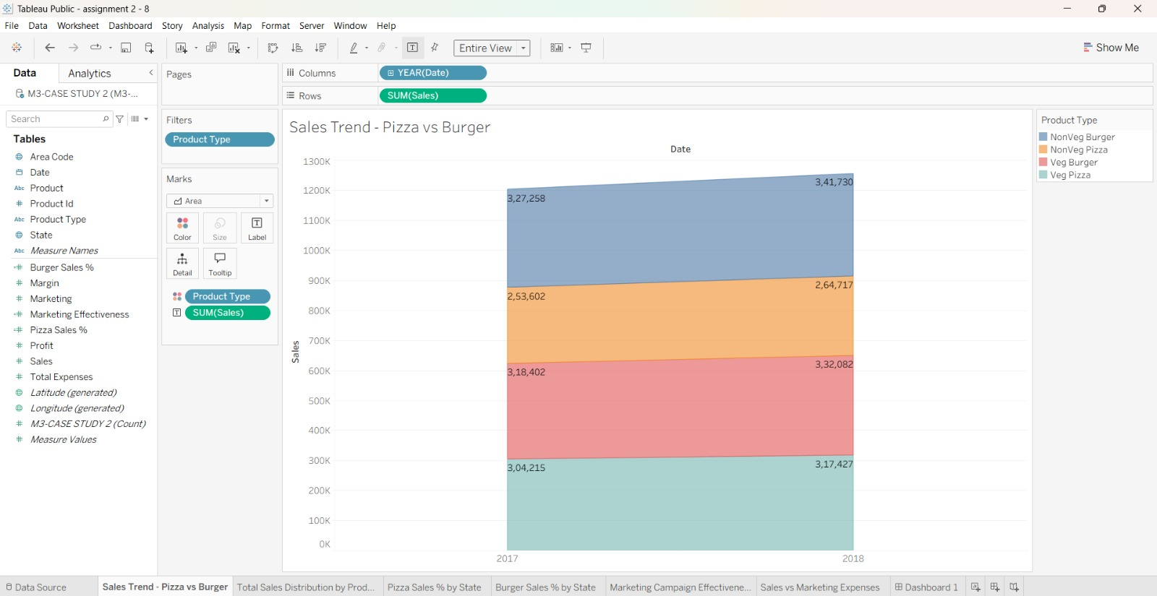

INTERPRETATION: The area chart compares the sales trends of Pizza and Burger over time. It helps identify changes in customer demand and determine which product category performs better during different periods. This analysis helps El Horno’s Pizza understand sales patterns and plan its inventory and marketing strategies accordingly.

- A Pie Chart and display Total Sales Distribution across product categories.
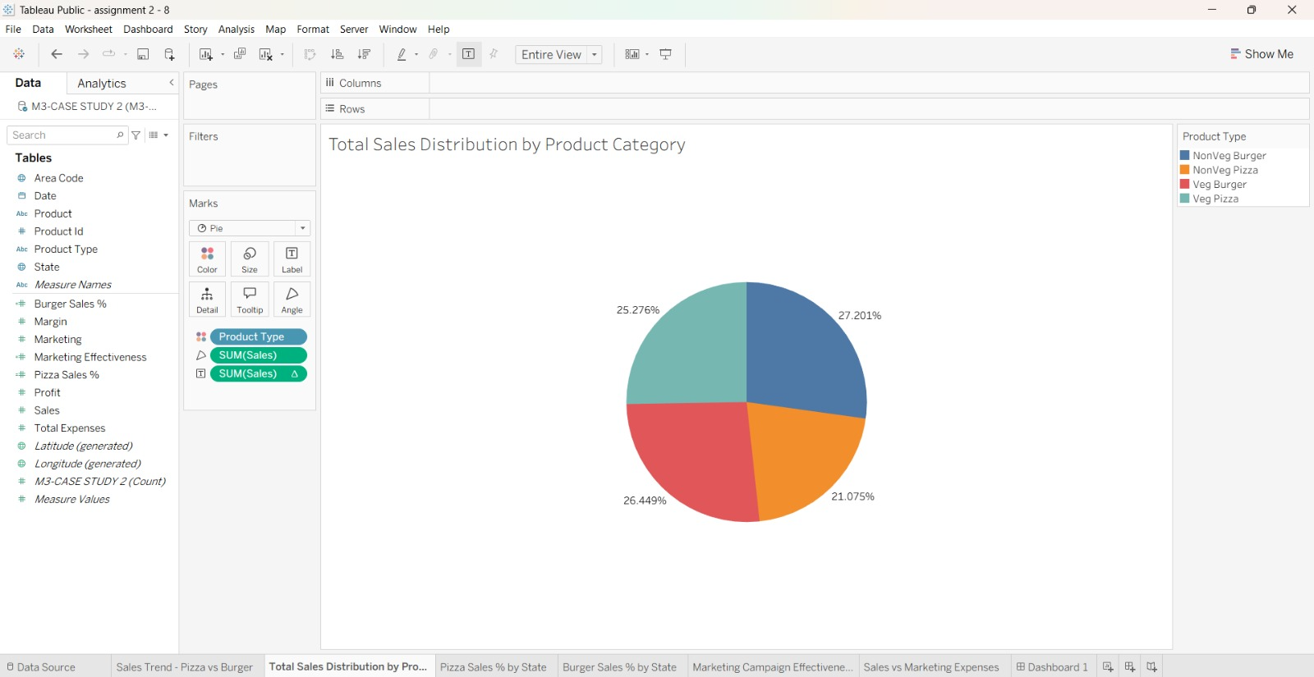

INTERPRETATION: The pie chart represents the contribution of Pizza and Burger to total sales. It helps identify which product category contributes the larger share of revenue and understand the overall sales distribution. This information supports decisions about product promotion and resource allocation.

- Sales distribution across product categories. Show a Chart by States which indicates the percentage of Pizza category sales across total sales.
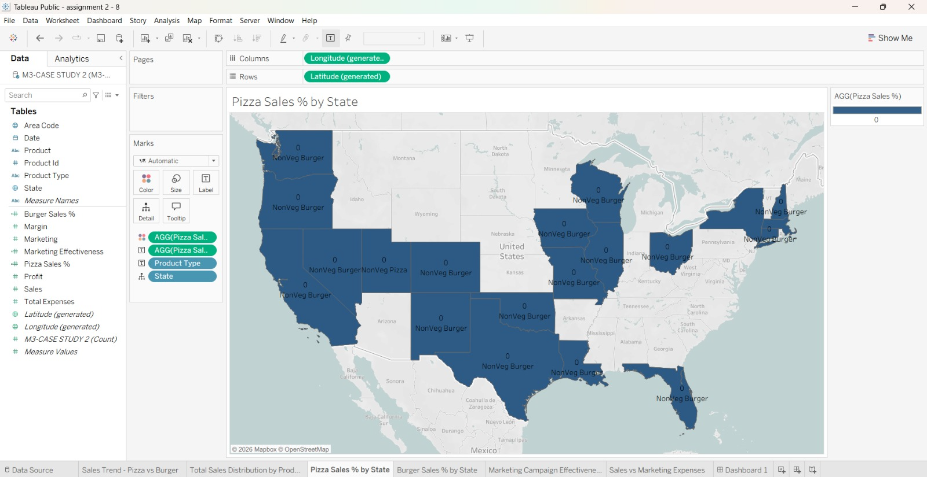

INTERPRETATION: This chart displays the percentage of Pizza sales relative to total sales across different states. It helps identify the states where Pizza contributes a larger share of sales and those where its contribution is lower. The company can use these insights to focus on high-performing markets and improve Pizza promotions in states with lower sales contributions.

- Sales distribution across product categories. Show a Chart by states which indicates the percentage of Burger category sales across total sales.
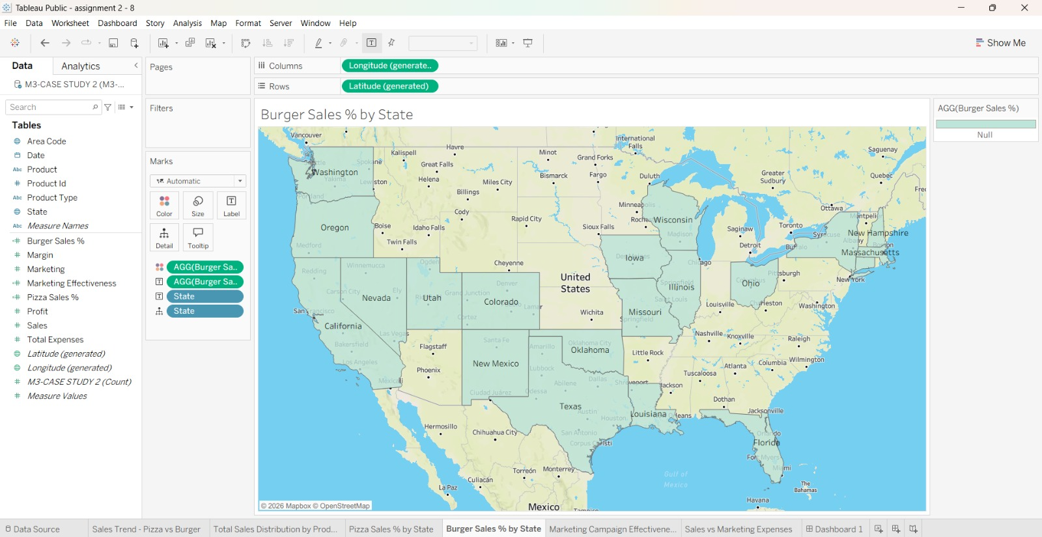

INTERPRETATION: This chart shows the percentage of Burger sales relative to total sales across different states. It helps compare Burger performance between states and identify areas with stronger or weaker sales contributions. The company can use this information to develop targeted marketing strategies and improve Burger sales in underperforming states.

- Identify the States, wherein the marketing campaigns are most effective and which of the marketing teams need to revise their tools? Show this on Vertical bar chart.
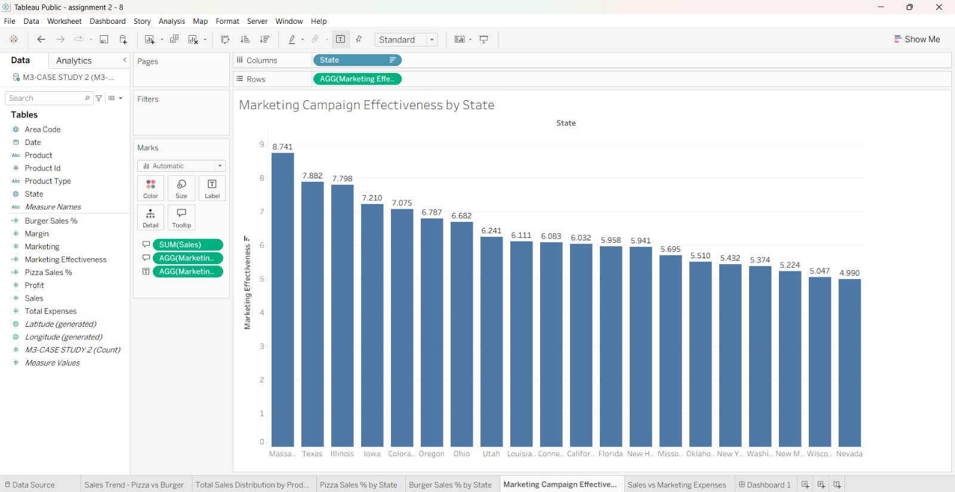

INTERPRETATION: The vertical bar chart compares marketing campaign performance across states. It helps identify states where marketing campaigns appear most effective and states where performance may require improvement. The marketing teams can use these findings to evaluate their existing strategies, revise promotional methods where necessary, and allocate marketing resources more effectively.

- A Scatter Plot and identify for correlation between Sales and Marketing Expenses, if any. Through Highlighting feature, identify for any changes within the years.

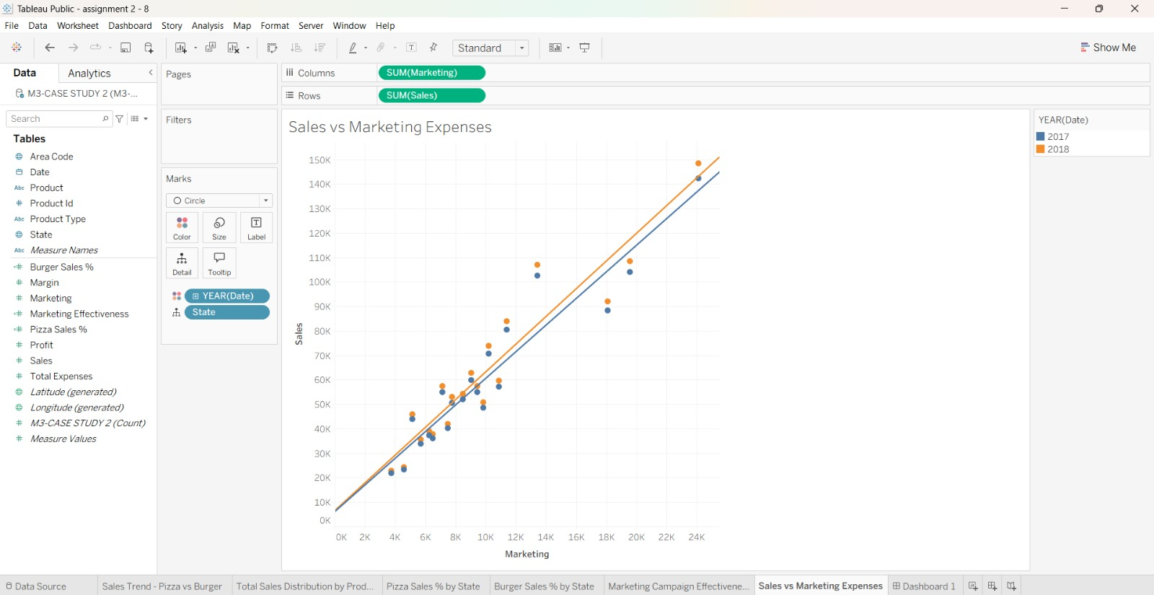

INTERPRETATION: The scatter plot examines the relationship between sales and marketing expenses. It helps determine whether higher marketing expenditure is associated with higher sales, lower sales, or no clear relationship. Highlighting changes across different years also helps identify variations in performance over time. These insights support better marketing budget allocation and campaign evaluation.

Overall Interpretation
The El Horno’s Pizza BI analysis provides insights into product sales trends, category-wise sales distribution, state-wise performance, marketing campaign effectiveness, and the relationship between sales and marketing expenses. The visualizations help the company identify strong and weak markets, understand customer demand for Pizza and Burger, and evaluate the effectiveness of its marketing strategies. By using these insights, El Horno’s Pizza can improve promotional planning, allocate marketing budgets more efficiently, strengthen underperforming regions, and make informed business decisions to improve overall sales performance.

